 

**AD23402**

**COMPUTER VISION SEMINAR**

*Submitted By*

**NAVEENKUMAR G**

**2023510016**

**B. Tech Information Technology (4/8)**

**DEPARTMENT OF INFORMATION TECHNOLOGY**

**MADRAS INSTITUTE OF TECHNOLOGY**

**ANNA UNIVERSITY, CHENNAI – 600 044**

January– April 2025

# LINEAR FILTERING-SOBEL FILTER

**1. Introduction**

Image processing is a crucial domain in computer vision, involving various techniques to analyze and manipulate images. One of the foundational tasks in image processing is edge detection, which helps in identifying object boundaries within an image. Edge detection is used to extract important features from images and reduce the amount of data to be processed. Among the many edge detection techniques, the **Sobel filter** is widely used due to its simplicity and efficiency.

**2. What is the Sobel Filter?**

The Sobel filter (or Sobel operator) is a discrete differentiation operator used to compute an approximation of the gradient of the image intensity function. It emphasizes edges in the horizontal and vertical directions, making it suitable for identifying boundaries and transitions in images.

The Sobel operator uses two 3x3 convolution kernels:

* One kernel detects changes in the horizontal direction (**Gx**)
* The other detects changes in the vertical direction (**Gy**)

**3. Sobel Kernels and Computation**

The kernels used in the Sobel operator are as follows:



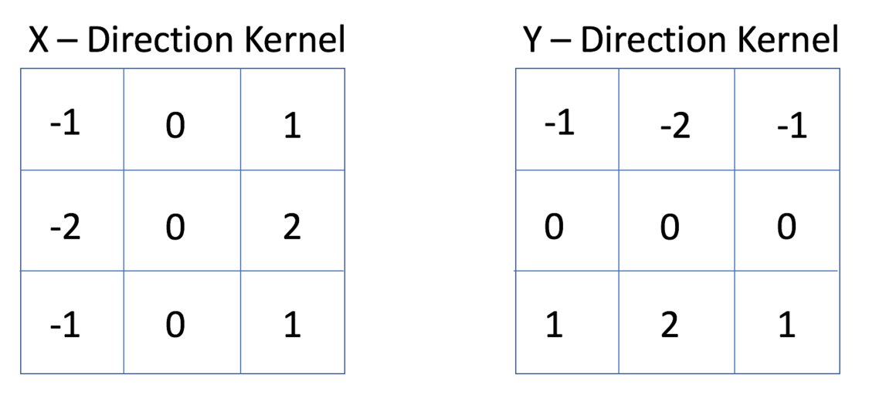

These kernels are convolved with the image to produce gradient components in both directions. Once the gradients are calculated, the overall edge strength (gradient magnitude) is determined by:

A common approximation for faster computation is:

This gradient magnitude is used to determine the presence and strength of edges at each pixel location.

At each point of the image we calculate an approximation of the *gradient* in that point by combining both results above:

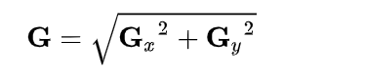

**4. Applications of Sobel Filter**

The Sobel operator has several applications in computer vision and image analysis, including:

* **Object boundary detection** in images
* **Lane detection** in autonomous vehicles
* **Preprocessing** in Optical Character Recognition (OCR)
* **Face detection** and recognition systems
* **Medical imaging** for detecting anatomical boundaries

**5. Advantages and Disadvantages**

**Advantages:**

* Simple and efficient for quick edge detection
* Highlights horizontal and vertical edges effectively
* Useful as a base for more complex vision tasks

**Disadvantages:**

* Sensitive to noise in the image
* Limited in detecting diagonal edges
* Not as accurate as more advanced detectors like Canny

**6. Comparison with Other Edge Detectors**

|  |  |  |
| --- | --- | --- |
| **Method** | **Type** | **Characteristics** |
| Sobel | First-order | Fast, detects vertical and horizontal edges |
| Prewitt | First-order | Similar to Sobel, simpler weights |
| Laplacian | Second-order | Detects all edges, very sensitive to noise |
| Canny | Multi-stage | Accurate, noise-resistant, detects thin edges |

**7. Conclusion**

The Sobel filter is an essential technique in edge detection and image processing. Its simplicity and efficiency make it a preferred choice for many basic applications. Though it may not be suitable for detecting fine details or diagonal edges, it serves as a strong foundation for understanding and implementing more advanced edge detection methods.

**8. References**

1. Rafael C. Gonzalez, Richard E. Woods - "Digital Image Processing"
2. https://docs.opencv.org/
3. https://en.wikipedia.org/wiki/Sobel_operator
4. Course material and seminar lecture notes